WMA Technical Specialist Team

Western Massachusetts Section
Mentoring Guide
For New Amateur Radio Operators

Your local club is:

Montachusett Amateur Radio ASSN.
PO Box 95
Leominster, MA 01853
Web: www.w1gz.org
Contact: Ray Lajoie AA1SE. aa1se@arrl.net
We meet at the Lunenburg Public Library at
1023 Mass Ave in Lunenburg on the second Wednesday of each month from September thru June. Meetings start at 7:00 PM

Local repeater frequencies:
145.450 offset -600 PL of 74.4 W1GZ repeater
147.315 offset +600 PL of 100.0 WB1EWS repeater

You can also find other repeaters across the country by going to www.repeaterbook.com

*** Use this page to provide your local club’s information, contact person, repeater, etc. and any other information for the new ham. ***

Add additional information such as mentor list, links, net’s technical resources important for the new ham.

Table of Contents

Table of Contents 3
Introduction 4
How to Find Technical Resources 5
The Technical Specialist (TS) Team 6
Operating Procedures and Etiquette* 8
Local Activities 9
Typical Commands 10
ITU Phonetic Alphabet 10
RST System 11
Q - Codes 12
UTC Time Conversion Chart 13
Using UTC Time Conversions 14
US Frequency Chart 15
HF Propagation 16
Additional Resources: 21
Tables 21
Amateur Radio Logbook 23
Logging software 24
Software for Digital Modes 28

ARRL® is a trademark of the American Radio Relay League
Windows® is a trademark of Microsoft Corporation
N1MM Logging®, Ham Radio Deluxe®, FLLog®, Log4OM®, Contesting Software® are possibly registered trademarks of the software provided by the websites mentioned in the Logging Software section below.

Introduction
Welcome to Amateur Radio !
It’s a fascinating hobby … one that is both immensely challenging and satisfying at the same time. But don’t be put off by the ‘challenging’ aspect as you can control just how much you immerse yourself in all its aspects depending precisely on what your interests are.
For example, you might be interested in Emergency Communications – and that is one of the key functions of Amateur Radio in serving our communities in times of disaster. If you have a hankering to build some of your own equipment, there are seminars, literature, and local help depending on how deep you want to get involved. If you have a competitive nature, then contesting is for you … there are myriad and frequent contests that span the State, Country or Globe that you can participate in!
There are many more aspects too numerous to mention here, but they all have one thing in common … you will probably need a bit of help in learning and initially doing each that you choose.
This is exactly what this document is about. It is a brief introduction to the help available to you via what we call Mentoring.
Simply, we depend on technical resources in your local radio clubs to be the first point of contact when you need help. Each club may have one or more members that are technically adept in certain areas that could initially help you. If further assistance is needed that person would refer the issue to an ARRL® Technical Specialist (TS) for your area. There is a listing of these folks further down in this document. If the TS needs additional resources, they can call on ARRL® help such as the ARRL® Lab to assist.
Individuals
Clubs
Club and Local Technical Help and Local Mentors
Technical Specialist Program
Mentoring Help
ARRL® Lab Assistance

How to Find Technical Resources

How do you find assistance with a technical issue? Who may help you out in specific situations?
The method of interaction for any issue should follow the flow chart on the previous page…
Your local club is your FIRST resource; if they need further assistance, the ARRL® Section Technical Specialist team will be there to help and they can enlist some additional ARRL® resources as needed …
… We’re ALL here to help YOU!!

When you are facing a technical issue, it is important to define what is actually happening versus what should be happening. A careful initial evaluation and definition of the problem on your part will greatly aid anyone that will be involved in assisting you.
The short table template below will help to frame the existing problem, and also to define what type of assistance may be required. Use it as a guide in critically thinking about and writing down the information it indicates. You’d be surprised how clarity can occur from noting differences and also describing the ‘actual’ vs. the ‘should’ behaviors.

DEVICE OR PROCESS | PROBLEM DESCRIPTION | WHERE does it occur? | WHEN does it occur? | SYMPTOMS | ACTION You’ve Taken | RESULT of that Action

Of course, this method lends itself easily to issues with hardware or software … the DEVICE can identify a club resource familiar with it to help with operating or performance issues. Similarly, the PROCESS can point you to a club member that can assist with HOW something gets done - by coaching, by example, or by providing a source of information needed. This describes the Mentoring aspect of the program. Perfection comes with practice, but it certainly helps to have someone guiding your initial efforts. Your local club may be a great resource in this area. If more resources are needed, the Technical Specialist for the area would then be called into play …

The Technical Specialist (TS) Team

If the resources of the local club become exhausted in dealing with an issue, the TS is available to assist you. The position description indicates that the TS …
- Serves as a technical advisor to local hams and clubs. Corresponds by telephone and letter on tech topics. Refers correspondents to other sources if specific topic is outside TS's knowledge.
- Serves as advisor in radio frequency interference issues. Local hams use the TS for guidance in dealing with interference problems.
- Speaks at local clubs on popular tech topics.
- Works with other ARRL® officials and appointees when called upon for technical advice, especially in emergency communications situations where technical prowess can mean the difference in getting a communications system up and running, the difference between life and death.
- Handles other miscellaneous technically - related tasks assigned by the Technical Coordinator.
Enlisting the TS for help is as simple as an email or call from the designated resource of your local club. The TS, along with you and your club resource, will examine the issue and establish a mutually acceptable means of communication going forward. Additional information may be requested to help in the evaluation process. If additional expertise is needed, the TS may contact ARRL® resources, on your behalf, to aid in resolving your issue.

Activities You Can Do!

Along with on the air nets, there are also local amateur radio related activities going on in the area. Check with your local club to find out what they enjoy.

Parks On the Air and National Parks on The Air (POTA or NPOTA) - see POTA413 on Facebook and NPOTA at www.npota.ARRL.org
Summits On the Air (SOTA) - www.sota.org/uk plus a local following, ask at a club meeting.
Skywarn - classes and weather activations. www.skywarn.org, Rob Macedo, KD1CY, rmacedo@rcn.com
Guidelines for operating at a public service event: http://www.ctsara.org/operating_public_service.pdf
Traffic handling- sending messages without phone or internet. A 100+ year old tradition still important today. See next page.
Interesting & Useful Ham Radio Links:
ARRL® - The American Radio Relay League, publisher of QST: www.ARRL.org
Space Weather: www.spaceweather.com
Space Weather Tutorial: www.spaceacademy.net.au/env/spwx/spwxtute.htm
IRLP = Internet Radio Linking Project, www.irlp.net
Echolink: www.echolink.org
QRZ.com: look up call letters and more
Eham.com: equipment reviews and much more
Large resource for ham radio: www.k0bg.com
Traffic handling: www.nts2@arrl.org www arrl.org/nts

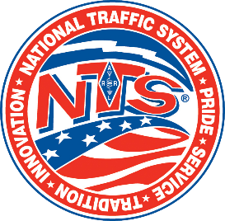
The National Traffic System

The National Traffic System was born around 1914 as the ARRL was formed. The American Radio RELAY League is where the name came from.

Back in the day of radio infancy, radios were quite crude and inefficient and was not able to transmit a signal a great distance like we enjoy today. Hiram Percy Maxim formed the club as a means to create a formal process of relaying messages across the country as mail, and later phones were long, non-existent, and sometimes expensive. Stations around the country would receive messages and relay to the next station and continues until it reaches its destination far quicker. This was a practice of message accuracy, technical skills, and operating skills to get the job done.

Fast forward 100 years! Why is it important today with cell phones and internet?

The National Traffic system over the years has demonstrated its value as a communication means as events over the course of history have caused critical failures during weather disaster’s, fires, and other sources of failure. Ham radio has been able to send critical information necessary without power, or transport means to keep information moving. Technology has changed dramatically but one thing is still there even if they think it will NEVER fail, simply it will fail! It has been proven many times with fiber cuts or meltdown due to fires. Hams are trained to deploy, setup a station and start transmitting in as little as 15 minutes. Battery, solar, wind, gas generator supplies the power to send messages, even EMAIL! Old fashioned Morse Code is still used, but voice and digital are also used. Many ways are now used to get messages to others which can save lives because we get it there fast and not rely on things that have failed.

There are nets held every day to give operators practice in sending and receiving traffic. They are on HF as well as VHF/UHF. Check your local area to find nets that you can learn and operate.

Operating Procedures and Etiquette*

Manuals and study guides may help you obtain your license, but they don’t really give you an idea of how you should act when you are on the air. They don’t tell you what to do and what not to do. Use the following as helpful suggestions in making your first of many contacts.

The best suggestion would be to listen before you transmit. Listen to other conversations to get an idea of what you need to say and abide by the ethics below:
· Be a good listener. It will help you better organize your thoughts before transmitting.
· Exercise politeness regardless of the circumstances. Whenever you begin to feel that you can’t, then stop transmitting.
· Speak clearly and slowly, especially when giving your call sign to someone you have not worked before.
· Make it clear at the end of every transmission which station is expected to transmit next whenever there are more than two stations in the conversation.
· Pause between transmissions. “Quick keying” gives the appearance that other hams are unwelcome in your QSO.
· Develop good operating practices. You will be doing your part in helping to insure the continuance of our long and proud tradition of self-regulation. Moreover, you might just convince someone else to become a ham.
*(courtesy Hampden County Radio Assn)
APPENDICES

Typical Commands

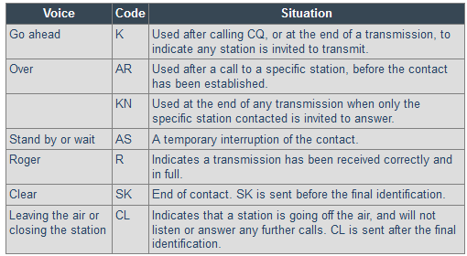

ITU Phonetic Alphabet
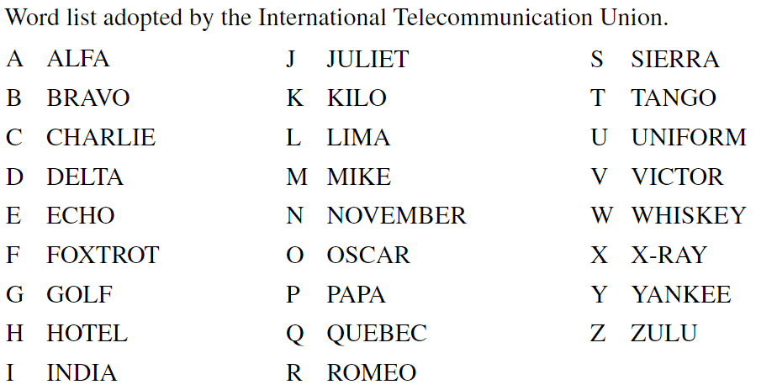

RST System

• Readability
1--Unreadable
2--Barely readable, occasional words distinguishable.
3--Readable with considerable difficulty.
4--Readable with practically no difficulty.
5--Perfectly readable.
• Signal Strength
1--Faint signals, barely perceptible.
2--Very weak signals.
3--Weak signals.
4--Fair signals.
5--Fairly good signals.
6--Good signals.
7--Moderately strong signals.
8--Strong signals.
9--Extremely strong signals.
• Tone
1--Sixty cycle a.c or less, very rough and broad.
2--Very rough a.c., very harsh and broad.
3--Rough a.c. tone, rectified but not filtered.
4--Rough note, some trace of filtering.
5--Filtered rectified a.c. but strongly ripple-modulated.
6--Filtered tone, definite trace of ripple modulation.
7--Near pure tone, trace of ripple modulation.
8--Near perfect tone, slight trace of modulation.
9--Perfect tone, no trace of ripple or modulation of any kind.

Most often during simplex communications operators will exchange a report with each other so operators will have an understanding in how their signals. Operators use what is known as the RST Code. RST stands for Readability, Strength and Tone. Operators will use a numbering system to inform the other operator how strong and clear their signal may or may not be. The T in RST is used on in CW (Morse code) communication where phone communications use just RS
If you hear someone say “you’re 5-9” while on SSB, that means you have a perfectly readable signal that is strong.
An example “Hello, this is Whiskey One Golf Zulu” would be more understandable than “Hello, this is W 1 G Z” in some situations. You might hear different phonetics as operators will make up their own, but it’s suggested to use the ITU/NATO phonetic set during formal nets and emergency related communications to keep uniformity.

Q - Codes

Q-codes are abbreviated meanings mainly used in Morse code (CW) communication. CW operators often use abbreviations and cut words to shorten the amount of characters one must send. It’s also beneficial during difficult to understand communications. Some of Q-Codes have carried over to both digital and voice communications. Here is a list of all the common Q-Codes.
Signal | Question/Answer | Signal | Question/Answer
QRG | Will you indicate my exact frequency | QSA | What is the signal strength of my signal?
QRH | Does my frequency vary? | QSB | Does the strength of signals vary?
QRI | How is the tone of my frequency? | QSD | Is my keying correct? Are my signals distinct?
QRJ | Are you receiving my badly? | QSG | Must I transmit… telegram(s) at a time?
QRK | What is the legibility of my signals (1-5)? | QSK | Shall I continue the transmission of all my traffic?
QRL | Are you busy? | QSL | Can you acknowledge receipt?
QRM | Is there interference | QSM | Shall I repeat the last telegram I sent you?
QRN | Are you troubled by static | QSO | Can you communicate with directly?
QRO | Must I increase power? | QSP | Will you reply to…..?
QRP | Must I decrease power? | QSV | Shall I send a series of VVV…?
QRQ | Must I send faster? | QSX | Will you listen for (call sign) on (frequency)?
QRS | Must I send slowly? | QSY | Shall I change frequency?
QRT | Must I stop transmission | QSZ | Shall I send each word or group twice?
QRU | Have you anything for me? | QTA | Shall I cancel nr… as if it had not been sent?
QRV | Are you ready? | QTB | Do you agree with my word count
QRW | Must I advise that you are calling? | QTC | How many telegrams have you to send?
QRX | When will you call again? | QTH | What is your position (location)
QRZ | By whom am I being called? | QTR | What is the exact time?

UTC Time Conversion Chart

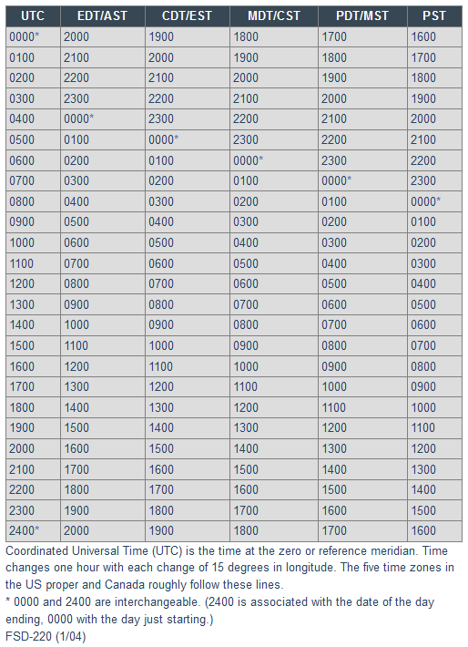

Using UTC Time Conversions

When it comes to making contacts on the air, most often operators will log their contacts into a logbook. Since it’s possible to make contacts around the world in different time zones, amateur radio operators will use Coordinated Universal Time (UTC) while logging. This allows easy confirmation (QSL) of contacts. Most often operators will also use the 24hr format. For example, 6pm in Massachusetts would be 18:00 local which would be 23:00 EST or 22:00 EDT in UTC. Use the chart below as reference
*= 0000 and 2400 are interchangeable. 2400 is associated with the date of the day ending 0000 with the day just starting
EDT – Eastern Daylight Time AST – Atlantic Standard Time
CDT – Central Daylight Time EST – Eastern Standard Time
MDT – Mountain Daylight Time CST – Central Standard Time
PDT – Pacific Daylight Time MST – Mountain Standard Time
PST – Pacific Standard Time

US Frequency Chart

Find the latest ARRL Frequency Chart at the ARRL website:

http://www.arrl.org/graphical-frequency-allocations

Source: - ARRL Website

The Frequency Chart determines what frequencies you may transmit on (and what operating modes you may use) depending on the class of your license. Other important information such as potential power limitations is also included in the appropriate places.

HF Propagation

Radio waves, like light waves and all other forms of electromagnetic radiation, normally travel in straight lines. Obviously, this does not happen all the time, because long - distance communication depends on radio waves traveling beyond the horizon. How radio waves propagate in other than straight-line paths is a complicated subject, but one that need not be a mystery. This page provides an introduction understanding the principles of electromagnetic radiation, the structure of the Earth's atmosphere and solar-terrestrial interactions necessary for a working knowledge of radio propagation. More detailed discussions and the underlying mathematics of radio propagation physics can be found in the references listed under additional resources.

The Sun, being the largest engine in our solar system, has a great effect on propagation as its "exhaust" interacts with our Earth's magnetic field. This and interactions with the atmospheric gases and particles at varying altitudes affects the densities of the ionospheric layers mentioned above, causing them to vary relative to the energy delivered from the sun’s light. A rudimentary knowledge of sunspots, solar flares and mass ejections will help the amateur take advantage of these effects to enhance his pleasure, or understand his plight.

There are a few variables we regularly consider to indicate “quality” of propagation impacting our operations - Solar Flux, the A-Index, and the K-Index. These values can be obtained from several sources on the internet or from radio transmissions from WWV, the time-standard station from the National Institute of Standards and Technology. Future projections of solar performance are also available from specific websites such as Space Weather.

Relative values for these factors and how they affect the propagation of our radio waves is indicated in the table on the following page.
HF Propagation: Some basic operational information relative to numbers you can find from various sources:

Solar Flux ranges from 30-300
A higher number is better.
30-70 Bad
80-90 Low
90-100 Average
100-150 Good
150-300 Ideal

A-Index ranges from 0-400
A lower number is better.
1-5 Ideal
6-8 Average
10-400 Bad

K-Index ranges from 0-9
A lower number is better.
0-1 Ideal
2-3 Good
4-5 Average
5-9 Bad

The following pages graphically illustrate some of the aspects of overall propagation that drive the behavior of your transmitted radio signal as it leaves or antenna for parts unknown.

Note: It is important to understand that the same exact same effects are being applied to the signals you are receiving from distant radio stations …. i.e. those that are not reaching you directly via line of sight of hugging the earth for relatively shorter distances (also known as ‘ground wave’).
There are several layers of the ionosphere at different altitudes above the earth’s surface. Altitudes and densities vary with differing conditions such as time of day and season.
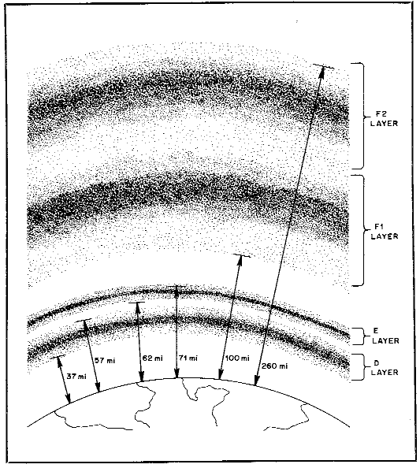
The layer of the ionosphere involved is frequency and time-of-day dependent as mentioned elsewhere in this paper. How your signal (radio wave) behaves with these layers determines how far your signal will travel … and what distant (DX) stations you may make contact with !

The above and following 3 charts appear in this publication HF Propagation: The Basics
QST December 1983, pp. 11-15
This article is referenced on the ARRL website: http://www.arrl.org/files/file/Technology/tis/info/pdf/8312011.pdf

Fig, 1 A radio wave can be reflected (or refracted) depending on several factors such as its frequency and the density of the ionospheric layer it is interacting with. It’s important to note that if the wave does not get refracted and return to the earth (or if it gets entirely absorbed by the layer) then it passes directly through the layer and out into space !
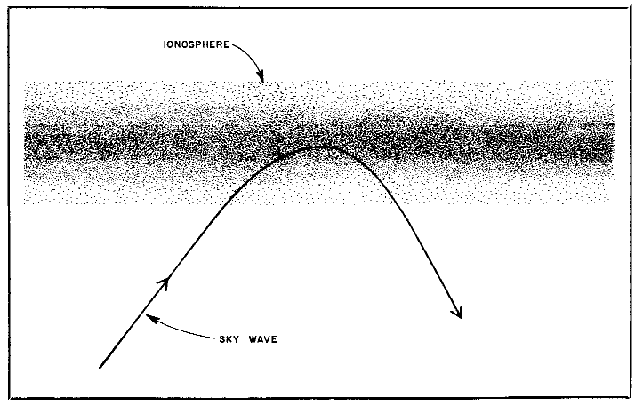

This refractive bending (which can be thought of as a ‘reflection’) is probably the most important determining factor of how far around the earth we can communicate!

The next page gives several graphic examples of how the ‘magic’ of HF propagation works.

Fig. 2 The distance where the radio wave returns to the surface is dependent upon the (A) frequency of the radio wave involved, and (B) how much the wave is bent or refracted … if at all !!
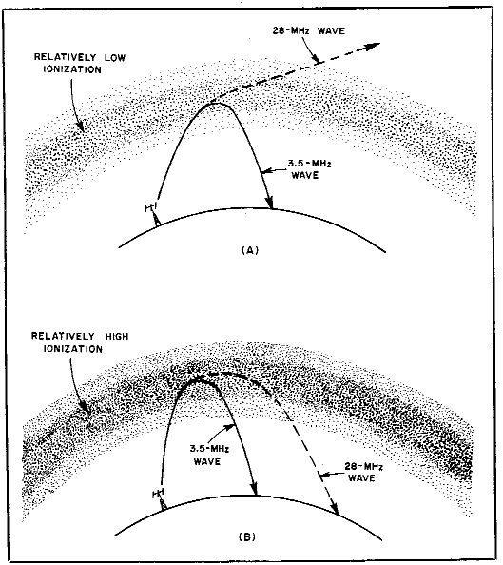
Fig.3 …and if multiple hops along the surface are involved with ground reflections as below.
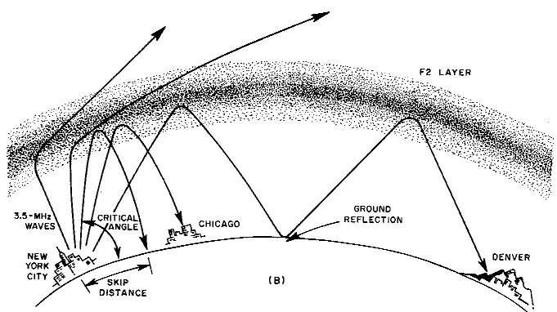

Additional Resources:
A good basic understanding of this can be had by reading the article "The Sun, the Earth, the Ionosphere." See also these other articles on propagation from the ARRL website http://www.arrl.org/propagation-of-RF-signals
You can get custom professional-grade high-frequency (3-30 MHz) propagation predictions online. https://www.hamqsl.com/solar3.html -a good prop site … or http://hflink.com/propagation/ HF NVIS Propagation

Tables
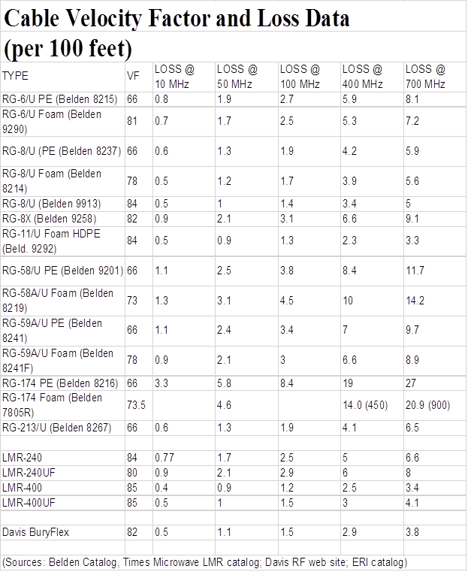
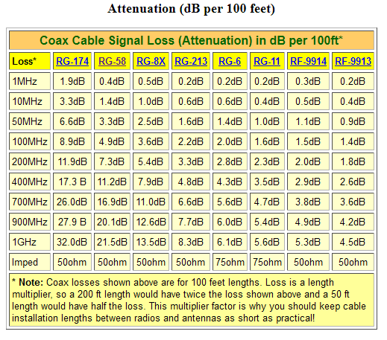
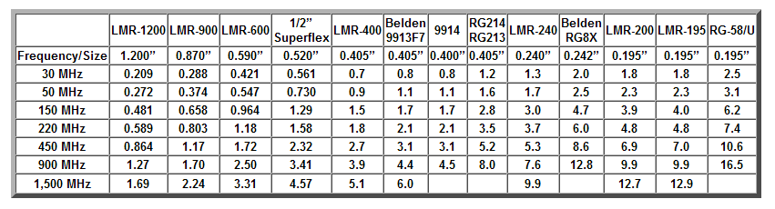

The above charts indicate typical sizes and characteristics of various sizes of coaxial cable as referenced by W4RP (https://www.w4rp.com/ref/coax.html)

Amateur Radio Logbook
The FCC no longer requires operators to log their contacts but it’s still common practice that many operators still do in many cases. Logs are used by operators to confirm that a contact did indeed take place.
On HF (3-30Mhz) communications, it’s common for operators to exchange postcards (called QSL cards) with contact details that could be used for certain awards like DXCC and WAS. If there is a computer nearby, there are many software packages that allow you to use your computer to log to contacts and some will even track your progress.
One of the most popular logging utilities used worldwide is Logbook of the World (LOTW). This is provided free by the ARRL®. Many stations will enter their contacts and gets confirmed when another station using LOTW will confirm the contact and you have an online contact database that actually can be used to submit for WAS and DXCC. Using your preferred logging software, you upload your contacts to LOTW. This has been a faster method for contact confirmation which has been slowly replacing QSL cards. You can learn more and download it on the ARRL®.org website
Your local resources should be able to guide you to the setup and use of logging software. Most logging software has very excellent support online and by email. Just like a car, video game, each one has their preference as to what they like. Check them out to see which one is best for you.
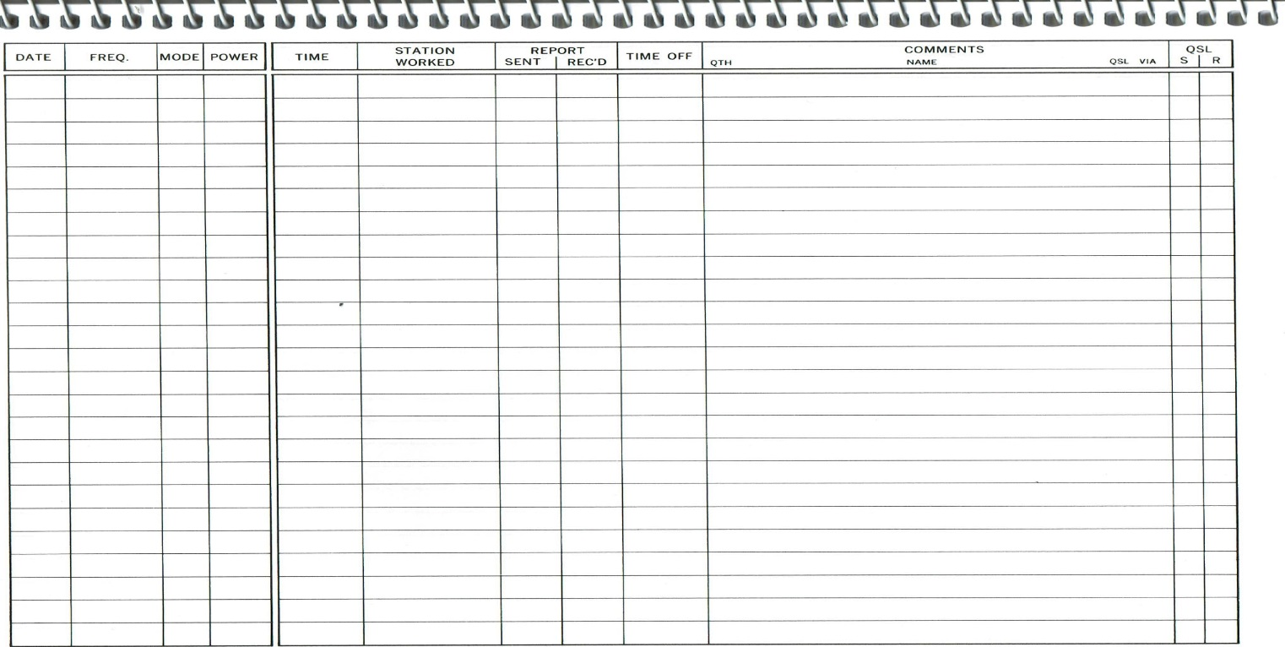

This is an example of a typical paper logbook page from Amateur Radio Station Logbook - an ARRL publication.

Logging software

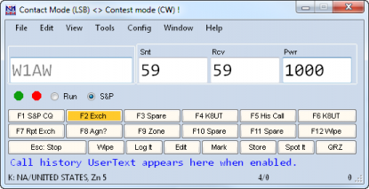
N1MM Logging® https://n1mmwp.hamdocs.com/

N1MM is one of the more popular pieces of logging software, it supports most contests and a large number of radios.
Cost: Free, Platform: Windows®

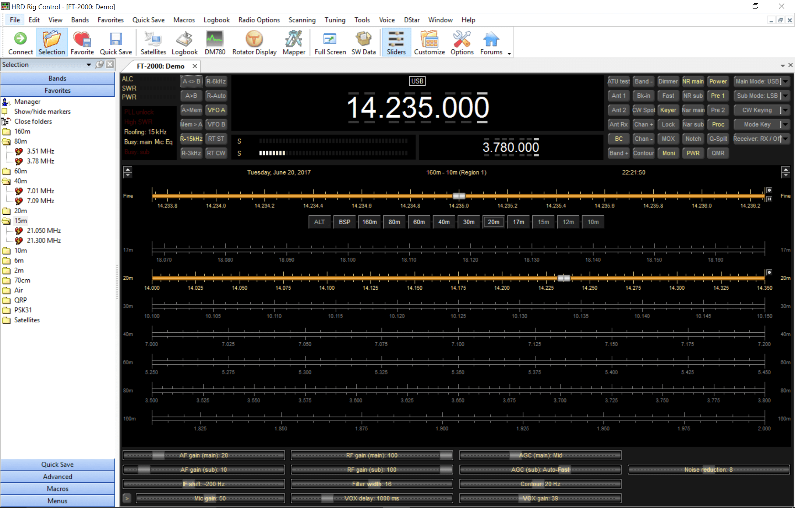
Ham Radio Deluxe® https://www.hamradiodeluxe.com/

One of the older software products, it combines logging and most digital modes with the exception of FT-8. It has a large support forum Base Cost: $124.94,
Platform: Windows®

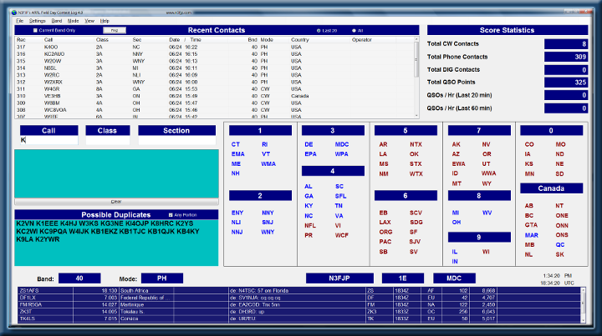
Contesting Software® http://www.n3fjp.com/

The author makes different program for different contests, the software is very popular with some contests.
Cost: Depends on the exact program, he also offers a bundle for all his software for $49.99, Platform: Windows®

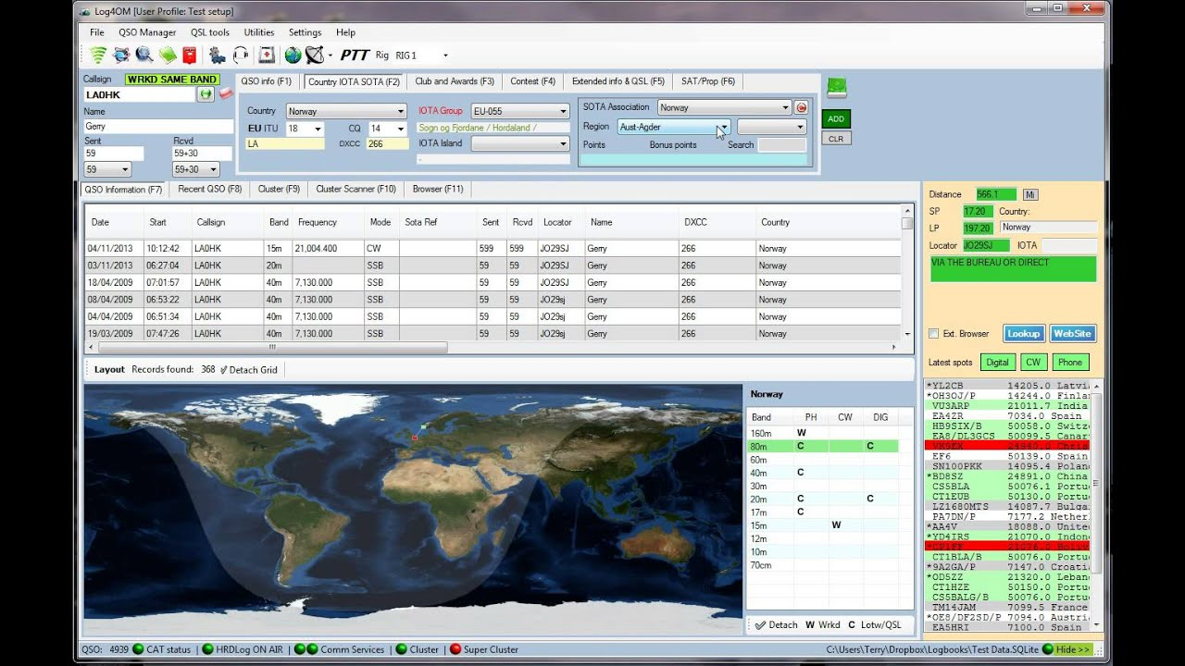
Log4OM® https://www.log4om.com/
Log4OM® is a flexible and easy to use and runs even on quite old Windows® hardware.
Cost: Free, Platform: Windows®

Software for Digital Modes
Both Ham Radio Deluxe and Fldigi (FlLog above) are popular platforms for operating digital, the various digital modes allow files, emails, text and other data to be sent via your ham radio.

Other software includes
WSJT-X https://physics.princeton.edu/pulsar/k1jt/wsjtx.html
js8call http://js8call.com/ These two software packages are for weak signal/low power communication and do not allow for very fast information exchange, but do allow for data to be sent even under the worst conditions.
WINLINK® specifically allows for the sending of email with your HF radio. WinLink Express is a program that allows transmission of email messages to a remote email user when the internet is down. This is accomplished by sending the message by radio to one of the hundreds of remote servers that are setup specifically to handle this traffic. The server (or Gateway) will take your rf email and place it back on the internet for delivery to the intended recipient. The recipient can then reply and one of the Gateways will pick this off the internet and send it to your station via radio the next time you connect to -any- Gateway in the system. This allows email use when a whole state or greater area has been compromised by weather or other situations … you simply choose to connect to any Gateway station that is outside the affected area. The WinLink software assists in identifying the strongest potential station for you to use and enlists current atmospheric conditions to help determine this.
Winlink http://www.winlink.org

IN CLOSING …

This guide is just a basic overview of how to find assistance for people new to or even interested in joining the hobby. Amateur radio offers an enormous diversity to suit your radio interests. We could not even start to include everything there is to offer. The good news is there is a vast wealth of information online and in publication form which will concentrate on what you are interested in … emergency communications, rare countries, Morse code, satellites, etc.
The best way to learn more about Amateur Radio is:
1. Find and join a local amateur radio club and utilize the technical resources there.
2. Join the ARRL®, which has many additional resources and a store where you can purchase books to learn more: www.ARRL.org.
Another avenue for assistance is groups that host “hamfests” or regional ARRL® conventions where there are forums you can attend and vendors you can visit.
As you can see, it is endless. We are here to assist you in your journey in radio… have fun!
Thank you … and 73
Your Western Massachusetts Technical Specialist Team

This document in generic form is available on https://wma.arrl.org/blog/2020/03/01/western-massachusetts-section-mentoring-program/

